**1.INTRODUCTION**

**1.1. Overview**

Plastic waste has become a defining environmental challenge of the 21st century, with India alone generating over 3.5 million tonnes of plastic waste annually. Despite various government and community-led initiatives, recycling rates remain suboptimal due to limited public participation, lack of incentives, and the absence of reliable, user-friendly recycling infrastructure. The unchecked accumulation of plastic waste leads to pollution, ecological imbalance, and health hazards for both humans and wildlife.

ReBottle Rewards emerges as a technology-driven solution to bridge this gap by incentivizing responsible plastic disposal. The system leverages a combination of IoT-enabled collection kiosks, advanced image recognition using Ultralytics YOLO, and Generative AI for intelligent bottle classification. When users deposit plastic bottles, the system verifies authenticity and type in real-time, awarding redeemable points for valid contributions. These points can be tracked and exchanged for rewards through a secure, intuitive web interface. By gamifying recycling and making it accessible, ReBottle Rewards aims to foster sustainable habits, enhance community engagement, and contribute to a cleaner, greener urban environment.

The platform’s architecture is designed for scalability and reliability, incorporating robust backend processing (using Flask and Python), secure data management (MySQL), and a user-centric frontend (AngularJS/Flask). This integrated approach not only streamlines the recycling process but also aligns with broader smart city and circular economy goals.

**1.2. Purpose of the Project**

The primary purpose of ReBottle Rewards is to increase plastic recycling rates by making the process both engaging and rewarding. The project seeks to address several key challenges in plastic waste management:

* **Motivating Participation:** By offering tangible rewards, the system encourages individuals to actively participate in recycling, transforming a mundane task into a rewarding experience.
* **Ensuring Accurate Classification:** The integration of Generative AI and Ultralytics YOLO enables precise identification and validation of plastic bottles, reducing contamination and improving recycling quality.
* **Supporting Environmental Sustainability:** By diverting plastic waste from landfills and promoting responsible disposal, the project contributes to ecological balance and resource conservation.
* **Empowering Communities:** The platform is designed for use in diverse settings-schools, residential complexes, public spaces, and corporate campuses-enabling widespread adoption and community involvement.
* **Facilitating Data-Driven Policy:** The system’s ability to track recycling behavior and waste patterns provides valuable insights for policymakers and environmental agencies.

**1.3 Scope of the Project**

ReBottle Rewards is envisioned as a **scalable, modular, and adaptable system** that can be implemented across various urban and semi-urban environments. The scope includes:

* **User Authentication & Profile Management:** Secure registration, login, and profile features, with encrypted password storage and robust authentication.
* **QR Code Scanning & Rewards System:** Real-time QR code generation and scanning to register recycling activities, with each transaction authenticated and logged.
* **AI-Driven Bottle Verification:** Utilizes Ultralytics YOLO for real-time object detection and Generative AI for advanced classification, ensuring only valid plastic bottles are accepted and rewarded.
* **Eco-Friendly Product Redemption:** Users can redeem earned points for a range of biodegradable and sustainable products, categorized by price, sustainability rating, and seller.
* **Fraud Detection Mechanism:** The system actively detects and prevents fraudulent recycling attempts, maintaining the integrity of the reward system.
* **Data Security & Privacy:** All user data and transactions are securely managed using MySQL and industry-standard security protocols.
* **Deployment Flexibility:** The system can be installed in educational institutions, residential societies, commercial centers, and public spaces, catering to a broad demographic.
* **Multi-Modal Integration:** While the current focus is on plastic bottles, the architecture allows for future expansion to other recyclable materials such as cans, packaging, and e-waste.
* **User Engagement and Gamification:** The reward-based model, combined with a user-friendly digital interface, enhances engagement and encourages repeat participation.
* **Smart City Alignment:** The platform supports integration with IoT devices and city-wide sustainability initiatives, making it a valuable component of smart city infrastructure.

**1.4 Definitions**

**1.4.1 Client-Server Architecture**

The **client-server architecture** is a distributed computing model in which tasks and workloads are divided between service providers (servers) and service requesters (clients). In the context of ReBottle Rewards, the client refers to the user interface-such as a web browser or mobile app-through which users interact with the system. The server is a centralized system that handles authentication, data processing, AI-based bottle validation, and reward management. This architecture enables multiple users to access the platform simultaneously, ensures secure management of user data, and supports scalability for future expansion. Communication between clients and the server is facilitated through standard internet protocols, making the system accessible from various devices and locations.

**1.4.2 Python**

**Python** is a high-level, open-source programming language renowned for its readability, versatility, and extensive library support. In ReBottle Rewards, Python serves as the backbone for backend development, enabling rapid prototyping, robust data handling, and seamless integration with advanced technologies. Libraries such as Flask are used for web development, OpenCV for image processing, and various AI frameworks for machine learning tasks. Python’s strong community support and cross-platform compatibility make it ideal for building scalable, maintainable, and secure applications.

**1.4.3 Generative AI**

**Generative AI** refers to a class of artificial intelligence models capable of generating, analyzing, and classifying complex data. In ReBottle Rewards, Generative AI is employed to evaluate deposited plastic bottles based on features such as design, shape, color, and material composition. This advanced analysis supports nuanced and accurate classification, ensuring that reward points are allocated fairly and consistently. Generative AI enhances the system’s ability to handle ambiguous or borderline cases, improving the overall quality and reliability of the recycling process.

**1.4.4 Ultralytics YOLO**

**Ultralytics YOLO (You Only Look Once)** is a cutting-edge, real-time object detection framework widely used for image recognition tasks. In the ReBottle Rewards system, Ultralytics YOLO enables the rapid and precise identification of plastic bottles as they are deposited into recycling machines. Its high speed and accuracy allow for immediate feedback to users and efficient processing of large volumes of recycling activity. By ensuring that only valid bottles are accepted and rewarded, YOLO upholds the integrity and trustworthiness of the platform.

**1.4.5 QR Code**

A **QR Code** (Quick Response Code) is a two-dimensional, machine-readable barcode that can store various types of information. In ReBottle Rewards, QR codes are generated by recycling machines to uniquely identify and verify each recycling transaction. Users scan these codes with their devices to register their activity, ensuring secure and traceable record-keeping.

**1.4.6 Recycling Machine**

A **recycling machine** in the ReBottle Rewards system is an IoT-enabled device designed to accept plastic bottles, verify their authenticity using AI-based detection, and generate a unique QR code for each valid deposit. These machines form the physical interface between users and the digital rewards platform, enabling automated, real-time validation and transaction logging.

**1.4.7 Reward Points**

**Reward points** are a form of virtual currency awarded to users for each valid plastic bottle recycled through the system. These points are securely stored in the user’s profile within the database and can be redeemed for eco-friendly products in the integrated marketplace. The reward system serves as a primary incentive, motivating users to participate actively in recycling.

**1.4.8 Eco-Friendly Products**

**Eco-friendly products** are items made from biodegradable, recyclable, or otherwise sustainable materials. Examples include bamboo cutlery, reusable food containers, and compostable packaging. By offering these products as rewards, ReBottle Rewards encourages users to adopt more sustainable consumption habits, reinforcing the environmental impact of their recycling efforts.

**1.4.9 Fraud Detection System**

The **fraud detection system** is an AI-powered mechanism embedded within ReBottle Rewards to ensure that only genuine plastic bottles are processed and rewarded. By leveraging advanced image recognition and data validation techniques, the system can detect and reject fraudulent or duplicate recycling attempts, maintaining fairness and accountability throughout the platform.

**1.4.10 Biodegradable**

A **biodegradable** material is one that can naturally decompose through the action of microorganisms, returning safely to the environment without causing harm. In the context of ReBottle Rewards, biodegradable products are prioritized in the rewards marketplace to promote environmentally responsible consumption and waste reduction.

**1.4.11 Sustainability**

**Sustainability** refers to the practice of using resources in a way that meets present needs without compromising the ability of future generations to meet their own needs. The ReBottle Rewards system is designed with sustainability at its core, aiming to reduce plastic pollution, conserve resources, and foster long-term environmental stewardship through technology and community engagement.

**2. LITERATURE SURVEY**

Here are few journals that researched based on this project:

**1. Consumer Behaviour in a Circular System – How Values Promote and Hinder the Participation of Young Adults in the Swedish Deposit-Refund System for Beverage Packaging, Anna Kremel (2023), Circular Economy and Sustainability, 4(2), 1427-1446.**

Kremel’s 2023 study delves into the psychological, social, and practical factors that affect young adults’ engagement with Sweden’s deposit-refund system. The research identifies convenience, financial rewards, and social influence (including peer pressure and a sense of guilt) as the most significant motivators for recycling. The study also highlights barriers such as inconvenience, time pressure, and social stigma, which can discourage participation even among environmentally conscious individuals. Kremel concludes that successful recycling programs must address both the emotional and practical needs of users, suggesting that a combination of tangible rewards and positive social reinforcement is key to maximizing engagement. The findings emphasize that recycling systems should be designed to be easy to use, visibly rewarding, and socially supported to overcome behavioral inertia.

**Outcome:** For our project, we are directly applying these insights by designing a gamified, user-friendly recycling experience that makes participation convenient and rewarding. The system’s point-based rewards, easy QR code scanning, and visible tracking of recycling history are intended to leverage both practical and social motivators. By making recycling feel rewarding and socially valued, we aim to maximize user engagement and long-term participation.

**2. Accessing Consumer Perceptions of the Effectiveness of the Deposit Refund System, Aggeliki Konstantoglou, Thomas Fotiadis, Dimitris Folinas, Athanasios Falaras, Konstantinos Rotsios (2023), Sustainability, 15(12), 9429.**

Konstantoglou et al. (2023) investigate public perceptions of deposit refund systems, focusing on the obstacles that prevent higher participation. The study finds that technical issues, limited access to recycling facilities, and lack of clear guidance are major barriers. Many participants reported confusion about where and how to recycle, and technical failures in machines discouraged repeated use. The authors stress the need for reliable, accessible, and user-friendly systems with clear instructions and responsive support. They recommend continuous user education, system refinement, and robust technical support to ensure high participation and satisfaction.

**Outcome:** From this paper, we have prioritized system reliability, intuitive interface design, and clear user guidance in our project. The Flask-based web interface is designed to be simple and direct, with step-by-step instructions and real-time feedback. We also ensure robust backend support and clear error handling, so users are never left confused or frustrated. This focus on usability and reliability is intended to remove barriers and encourage consistent recycling behavior.

**3. Wireless Internet-Connected Incentive System for Collecting Plastic Bottles, Emarve G. Gito, Josefina R. Sarmiento, Marco L. Espinosa (2024), Global Science Journals, 12(3).**

Gito et al. (2024) present a working prototype of a wireless, internet-connected incentive system for plastic bottle collection. Their research demonstrates that an intuitive interface, immediate reward feedback, and effective bottle segregation significantly boost both user engagement and recycling efficiency. The system’s real-time feedback loop and gamified rewards encourage users to participate more frequently and with greater enthusiasm. The authors highlight that integrating technology for instant validation and reward distribution not only increases recycling rates but also improves data collection and management for authorities.

**Outcome:** We have adopted a real-time, technology-driven approach in ReBottle Rewards, using AI-powered image recognition (Ultralytics YOLO and Generative AI) to instantly validate bottles and award points. The immediate feedback and visible reward system are designed to create a positive feedback loop, encouraging repeat participation. Additionally, our system’s data-driven backend allows for detailed tracking and future analytics, supporting both user engagement and operational efficiency.

**4. Spin the Bottle Bill: Deposit-Refund System Policy and Reverse Supply Chain Design, Austin Saragih, Lara Pontes, Saurabh Amin, Jan C. Fransoo (2024), MIT Center for Transportation & Logistics Research Paper No. 2024/010.**

Saragih et al. (2024) analyze how policy, system design, and reverse logistics interact to determine the success of deposit-refund systems. The paper emphasizes that combining reliable technical features (such as AI-based detection and validation), well-structured incentive strategies, and user convenience is essential for maximizing recycling rates and environmental impact. The authors argue that effective policy support, efficient collection and processing logistics, and user-centric design must all work together for optimal results. They also note that systems should be scalable and adaptable, capable of expanding to new products or geographies as needs evolve.

**Outcome:** We are implementing a holistic system that integrates advanced technical validation (AI-powered image recognition), a robust incentive structure (points and eco-friendly rewards), and a user-centric interface. Our project is also designed for scalability, with modular components that can be expanded to new locations or additional recyclable materials. By aligning with these best practices, we aim to ensure both immediate effectiveness and long-term adaptability.

**5. Reduce, Reuse, Redeem: Deposit-Refund Recycling Programmes in the Presence of Alternatives, Peter Berck, Molly Sears, Rebecca L.C. Taylor, Carly Trachtman, Sofia B. Villas-Boas (2024), Ecological Economics, 217, 108080.**

Berck et al. (2024) compare deposit-refund recycling programs with alternative waste management approaches. Their research finds that financial incentives are important, but convenience, social context, and perceived effort are equally influential in determining recycling behavior. The paper reveals that income and education levels affect preferences: higher-income individuals value convenience and automation, while lower-income groups are more motivated by direct cash rewards. The authors recommend designing flexible programs that can cater to different user segments and highlight the importance of integrating both social and economic incentives.

**Outcome:** We have designed ReBottle Rewards to be flexible and inclusive, offering a convenient, automated recycling process that appeals to a broad demographic. The point-based rewards can be redeemed for eco-friendly products, catering to users motivated by both convenience and tangible benefits. Our system is also designed to be scalable and adaptable, with the potential to introduce additional reward types or recycling categories in the future, ensuring that we can meet the needs of diverse user groups.

**3.PROBLEM IDENTIFICATION**

**3.1 Problem Identification**

Plastic waste management remains a critical environmental challenge globally, with vast quantities of non-recycled plastic accumulating in landfills, rivers, and oceans. Traditional recycling systems face several persistent issues:

* **Manual Sorting Inefficiencies:** Most recycling processes rely on manual sorting, which is time-consuming, error-prone, and often leads to misclassification and contamination of recyclables.
* **Lack of Automation:** There is a notable absence of automated systems that can efficiently and accurately evaluate the quality and type of plastic waste at the point of collection.
* **Limited Consumer Motivation:** Without tangible incentives or feedback, individuals often lack motivation to participate in recycling programs, resulting in low public engagement.
* **Awareness and Transparency Gaps:** Consumers are rarely able to track their recycling contributions or understand the environmental impact of their actions, further reducing motivation.
* **Inadequate Data Tracking:** Existing systems do not provide users or administrators with transparent records of recycling activity, reward accrual, or environmental benefits.
* **Scalability and Accessibility Issues:** Many recycling initiatives are limited to urban areas and do not scale efficiently to serve diverse communities, including rural or underserved populations.

The ReBottle Rewards project addresses these challenges by introducing an AI-driven, automated recycling solution. By leveraging advanced image recognition (YOLO/OpenCV and Generative AI) and IoT-enabled smart machines, the system automates plastic quality assessment, reduces manual errors, and streamlines the recycling process. Integrated reward-based incentives encourage responsible disposal, while a digital platform allows users to track their recycling history, redeem points for eco-friendly products, and contribute to sustainability goals in a transparent and engaging manner.

**3.2 Problem Statement**

The ReBottle Rewards system is designed to tackle the multifaceted challenges of plastic waste management, specifically:

* **Inefficient Sorting Mechanisms:** Traditional recycling depends on manual labor, resulting in slow, error-prone, and inconsistent sorting of plastic waste.
* **Limited User Engagement:** The absence of structured incentives and feedback discourages individuals from participating in recycling initiatives.
* **Lack of Automation:** There is a need for an end-to-end, automated solution capable of accurately classifying and processing recyclables.
* **Data and Transparency Deficits:** Users are unable to monitor their recycling activities, rewards, or environmental impact in real time.

**Problem Statement:** "To develop an integrated, AI-driven plastic recycling platform that automates plastic quality assessment, incentivizes responsible disposal through a reward-based system, and provides a transparent, user-friendly digital interface for tracking recycling activities and redeeming rewards."

**Input:** Plastic bottles deposited into IoT-enabled recycling machines, with images captured for AI-based analysis.

**Output:**

* Automated validation and classification of plastic bottles.
* Real-time allocation of reward points to user accounts.
* Transparent tracking of recycling history and environmental impact.
* Seamless reward redemption through a digital marketplace.

**3.3 Project Scope**

The scope of the ReBottle Rewards project encompasses the following:

* **Automated Plastic Detection and Classification:** Utilizes camera-based image capture, YOLO object detection, and Generative AI to accurately identify and verify plastic bottles in real time.
* **IoT-Enabled Smart Machines:** Integrates servo-controlled intake mechanisms to accept or reject bottles based on AI validation, ensuring only valid recyclables are processed.
* **Reward-Based Incentive System:** Assigns redeemable points for each valid bottle deposited, with points stored in a secure MySQL database linked to user profiles.
* **User-Friendly Digital Platform:** Provides a Flask-based web interface for users to register, scan QR codes, view recycling history, and redeem points for eco-friendly products.
* **Fraud Detection and Data Security:** Employs advanced fraud detection algorithms and secure authentication to prevent abuse and protect user data.
* **Behavior-Driven Engagement:** Incorporates gamification and real-time feedback to boost participation, leveraging convenience, social rewards, and environmental awareness.
* **Scalable and Expandable Design:** Designed for deployment in schools, communities, public spaces, and potentially across broader geographies. The system can be extended to include other recyclable materials and enhanced with additional AI capabilities.
* **Environmental and Social Impact:** Promotes sustainable practices, supports circular economy principles, and enables users to contribute meaningfully to environmental conservation.

By addressing these challenges and defining a clear, scalable scope, ReBottle Rewards aims to transform plastic waste management into an efficient, engaging, and impactful process for individuals and communities alike.

**4.Project Goals and Objectives**

**4.1. Project Goals**

1. **Promote Responsible Plastic Disposal:** Encourage individuals and communities to recycle plastic bottles by making the process engaging, accessible, and rewarding.
2. **Leverage Technology for Efficient Recycling:** Integrate AI-powered image recognition and IoT-enabled machines to automate plastic bottle detection, classification, and validation, reducing manual errors and inefficiencies.
3. **Foster Environmental Sustainability:** Support the circular economy by increasing plastic recovery rates, reducing landfill waste, and promoting the use of eco-friendly products.
4. **Enhance User Engagement and Awareness:** Use gamification and a transparent reward system to motivate users, track their recycling activities, and raise awareness about the environmental impact of their actions.
5. **Enable Scalable and Reliable Waste Management:** Develop a robust, secure, and scalable platform that can be deployed in schools, communities, public spaces, and potentially expanded to other recyclable materials.

**4.2. Project Objectives**

1. **Automated Plastic Bottle Detection and Classification:** Implement real-time image capture and AI-based evaluation (using YOLO/OpenCV and Generative AI) to accurately detect and verify plastic bottles deposited in recycling machines.
2. **Reward-Based Incentive System:** Assign redeemable points for each valid bottle, with points stored in a secure MySQL database linked to user profiles. Allow users to redeem points for eco-friendly products through an integrated digital marketplace.
3. **User-Friendly Digital Platform:** Provide a simple, intuitive web interface (built with Flask) for users to register, scan QR codes, track recycling history, and manage rewards. Ensure seamless navigation, real-time feedback, and transparent display of points and environmental impact.
4. **Fraud Detection and Data Security:** Integrate advanced fraud detection algorithms to prevent abuse and ensure only genuine plastic bottles are rewarded. Protect user data and transaction records with industry-standard security protocols.
5. **Behavior-Driven Engagement:** Encourage participation through gamified experiences, social rewards, and environmental awareness campaigns. Provide real-time notifications and visible progress tracking to reinforce positive recycling behavior.
6. **Scalability and Expandability:** Design the system architecture to support easy scaling to new locations and user groups. Enable future enhancements, such as integration with IoT-enabled smart bins, blockchain-based rewards, and expansion to other recyclable materials.
7. **Support for Policy and Industry Initiatives:** Align the platform with smart city, corporate social responsibility (CSR), and regulatory compliance initiatives, enabling businesses and governments to meet sustainability goals.
   1. **PROJECT REQUIREMENTS**

ReBottle Rewards is a comprehensive, technology-driven platform for incentivized plastic recycling. The project requires a blend of hardware and software components, as well as clearly defined functional and non-functional requirements to ensure system reliability, scalability, and user satisfaction.

**5.1 Hardware Requirements**

* **IoT-Enabled Recycling Machine:** Accepts plastic bottles, houses the camera, and interfaces with the backend for real-time validation and point allocation.
* **Camera/Webcam:** Captures high-resolution images of deposited plastic bottles for AI-based analysis and classification.
* **Servo Motor:** Controls the intake mechanism to accept or reject bottles based on AI validation results.
* **Microcontroller (e.g., Arduino/ESP32):** Manages the servo motor and interfaces with sensors and actuators for automated bottle handling.
* **QR Code Display Module:** Generates and displays unique QR codes for each successful recycling transaction, enabling user activity registration.
* **Wi-Fi Module (integrated with microcontroller):** Provides wireless connectivity for real-time data transfer between the recycling machine and the backend server.
* **Power Supply:** Ensures stable operation of all electronic components, including the camera, microcontroller, and servo motor.
* **System (PC/Laptop/Server):** Hosts the backend application, database, and AI models, and provides administrative access for monitoring and maintenance.

**5.2 Software Requirements**

* **Python:** Primary programming language for backend development, AI integration, and automation scripts.
* **Flask:** Lightweight web framework used to build the backend server, handle API requests, and manage user authentication.
* **MySQL:** Relational database for secure storage of user data, transaction logs, reward points, and product catalogs.
* **Ultralytics YOLO:** State-of-the-art object detection framework used for real-time plastic bottle identification and validation.
* **Google Generative AI (Gemini or similar):** Advanced AI model for nuanced classification of bottle types and quality assessment.
* **OpenCV:** Image processing library used for capturing, preprocessing, and analyzing bottle images.
* **AngularJS/HTML/CSS/JavaScript:** Technologies for building a responsive, user-friendly frontend interface, enabling users to track rewards, view recycling history, and shop for eco-friendly products.

**5.3 Functional Requirements**

* **User Registration and Authentication:** Users must be able to create accounts, log in securely, and manage their profiles.
* **Bottle Image Capture and Detection:** The system must capture images of deposited bottles and process them using AI models for validation.
* **Automated Bottle Acceptance/Rejection:** The machine must accept or reject bottles based on AI validation, ensuring only valid plastic bottles are rewarded.
* **Reward Points Allocation:** Users must receive points for each valid bottle, with points updated in real-time and stored in their profiles.
* **QR Code Scanning and Transaction Logging:** Each recycling transaction must generate a unique QR code, which users scan to register their activity and claim points.
* **Eco-Friendly Product Redemption:** Users must be able to redeem accumulated points for sustainable products through an integrated digital marketplace.
* **Fraud Detection:** The system must detect and prevent fraudulent recycling attempts, ensuring fairness and integrity.
* **User Dashboard:** Users must be able to view their recycling history, points balance, and reward redemption status.

**5.4 Non-Functional Requirements**

* **Scalability:** The system should support growth in user base, transaction volume, and geographic reach without performance degradation.
* **Reliability:** The platform must ensure consistent operation, accurate points allocation, and robust error handling.
* **Security:** User data, transactions, and authentication must be protected using encryption and secure protocols.
* **Usability:** The user interface should be intuitive, accessible, and responsive across devices.
* **Performance:** Real-time image processing and points allocation should occur with minimal latency.
* **Maintainability:** The codebase and system architecture should allow for easy updates, bug fixes, and feature enhancements.
* **Interoperability:** The system should be compatible with various hardware modules and support integration with third-party services or IoT devices.

**6. SYSTEM DESIGN & IMPLEMENTATION**

**6.1 System Architecture**

This layered architecture ensures that ReBottle Rewards provides a seamless, automated, and engaging experience for users, while maintaining system reliability, scalability, and security throughout the recycling and reward process.

**1. Input Layer: Bottle Acquisition & User Interaction**

* IoT-Enabled Recycling Machine: Accepts plastic bottles and initiates the recycling process.
* Camera/Webcam Module: Captures high-resolution images of each deposited bottle for analysis.
* QR Code Display: Generates and displays a unique QR code for each transaction, allowing users to register their recycling activity via scanning.

**2. Processing Layer: AI-Based Validation & Reward Calculation**

* Ultralytics YOLO Model: Performs real-time object detection to verify that the deposited item is a valid plastic bottle.
* Google Generative AI Model: Further classifies the bottle based on design, shape, color, and material for quality assessment and point allocation.
* Python Scripts: Manage image preprocessing, AI inference, and integration between hardware and backend systems.

**3. Control Layer: Machine Automation & Feedback**

* Microcontroller (e.g., Arduino/ESP32): Controls the servo motor to accept or reject bottles based on AI validation results.
* Servo Motor: Physically allows or denies bottle entry into the machine, ensuring only valid bottles proceed.
* Status Indicators: LEDs or display screens provide immediate feedback to users on the acceptance or rejection of their bottle.

**4. Communication Layer: Data Transfer & Integration**

* Wi-Fi Module: Enables real-time communication between the recycling machine and the backend server.
* Server Communication: Transmits bottle validation results, user activity, and reward points to the central database.
* Notification System: Sends real-time updates to users about successful recycling, points earned, and reward status via the web interface.

**5. Presentation Layer: User Web Interface**

* Login & Registration Page: Allows users to securely create accounts and authenticate.
* Dashboard: Displays the user’s recycling history, points balance, and recent activity.
* QR Code Scanner: Enables users to scan QR codes generated by the machine to register their recycling actions.
* Shop/Marketplace: Lets users redeem accumulated points for eco-friendly products and view product details.
* Points Redemption & Cart: Facilitates the selection and checkout of products using reward points.
* Support & Contact Page: Provides help, FAQs, and contact options for user assistance.
* About & Impact Page: Informs users about the environmental impact of their recycling efforts and the journey of collected bottles.

**6.2 Input / Output Design**

This Input/Output design ensures seamless data flow, real-time feedback, and an engaging user experience throughout the ReBottle Rewards recycling and reward process.

**Input Design**

* **Plastic Bottle Images:** Captured in real time by the camera/webcam module embedded in the IoT-enabled recycling machine for AI-based analysis and validation.
* **User Credentials:** Entered by users during registration and login on the web interface to access their profiles, track rewards, and redeem points.
* **QR Code Scans:** Users scan machine-generated QR codes to register their recycling activity and link each deposit to their account.
* **Labeled Training Data:** Used to train the Ultralytics YOLO and Generative AI models for accurate plastic bottle detection, classification, and quality assessment.
* **Bottle Attributes:** Data such as bottle shape, color, and design, captured and labeled for AI evaluation and point allocation.
* **Reward Redemption Requests:** User-initiated actions to redeem accumulated points for eco-friendly products via the digital marketplace.

**Output Design**

* **Validation Result:** The system outputs whether the deposited item is a valid plastic bottle, as determined by the AI models.
* **Acceptance or Rejection Signal:** The microcontroller triggers the servo motor to accept or reject the bottle based on validation results, providing immediate physical feedback.
* **Points Allocation:** Reward points are credited to the user’s profile in real time, with the value determined by the AI’s evaluation of the bottle.
* **QR Code Generation:** A unique QR code is generated and displayed for each successful recycling transaction, allowing users to claim their points.
* **Web Dashboard Updates:** Users can view their updated points balance, recycling history, and recent transactions on the web interface.
* **Product Redemption Confirmation:** Upon successful redemption, the system confirms the transaction and updates the user’s points and order status.
* **Notifications & Alerts:** Real-time notifications are sent to users for successful deposits, points earned, and reward redemptions.
* **Admin Console Logs:** System outputs, transaction logs, and error messages are displayed on the admin console for monitoring and debugging.

**6.3 Workflow Design**

The ReBottle Rewards system delivers a seamless, technology-driven recycling and rewards experience, as illustrated in Figure 1. The process begins with user registration and authentication, ensuring secure access to personalized features. Upon successful login, users are directed to the home page, where they can manage their profile, seek customer support, or proceed to the recycling or shopping modules.

To recycle, users scan a QR code displayed on the recycling machine, establishing a secure link between their profile and the machine. If users are not logged in, the system prompts for proper credentials, maintaining data security and personalized tracking.

Once authenticated, users insert a plastic bottle into the machine. The system leverages a camera module to capture an image of the deposited bottle. This image is processed by an AI-based validation pipeline:

* Ultralytics YOLO performs real-time object detection to confirm the presence and type of plastic bottle.
* Google Generative AI further classifies the bottle based on shape, color, and design, ensuring nuanced and accurate evaluation.

The AI-driven fraud detection mechanism ensures only eligible, recyclable bottles are accepted. If the bottle does not meet the criteria, the user receives an immediate notification to try again, promoting transparency and trust in the system.

For valid bottles, the servo-controlled intake mechanism accepts the bottle, and the system automatically credits reward points to the user’s profile. Points are allocated based on the AI’s assessment, ensuring fairness and consistency. A unique QR code is generated for each successful transaction, which the user scans to confirm and log their activity.

Users can access their profile dashboard at any time to view their recycling history, accumulated points, and environmental impact. The “Shop Items” section allows users to browse eco-friendly products and add items to their cart. Points can be redeemed for products directly through the web interface, or users may choose to pay using standard methods.

Customer support is available throughout the process for any queries or issues. After key interactions-such as successful recycling or reward redemption-the system sends confirmation emails to users, enhancing communication and engagement.

All user data, transactions, and AI evaluations are securely managed in a MySQL database, with the backend powered by Flask and the frontend built using AngularJS and modern web technologies. The architecture ensures real-time feedback, robust security, and scalability for broader deployment in schools, communities, and public spaces.

By integrating AI-driven validation, IoT-enabled automation, and a gamified rewards platform, ReBottle Rewards not only simplifies recycling but also motivates sustained eco-friendly behavior and supports the transition to a circular economy.

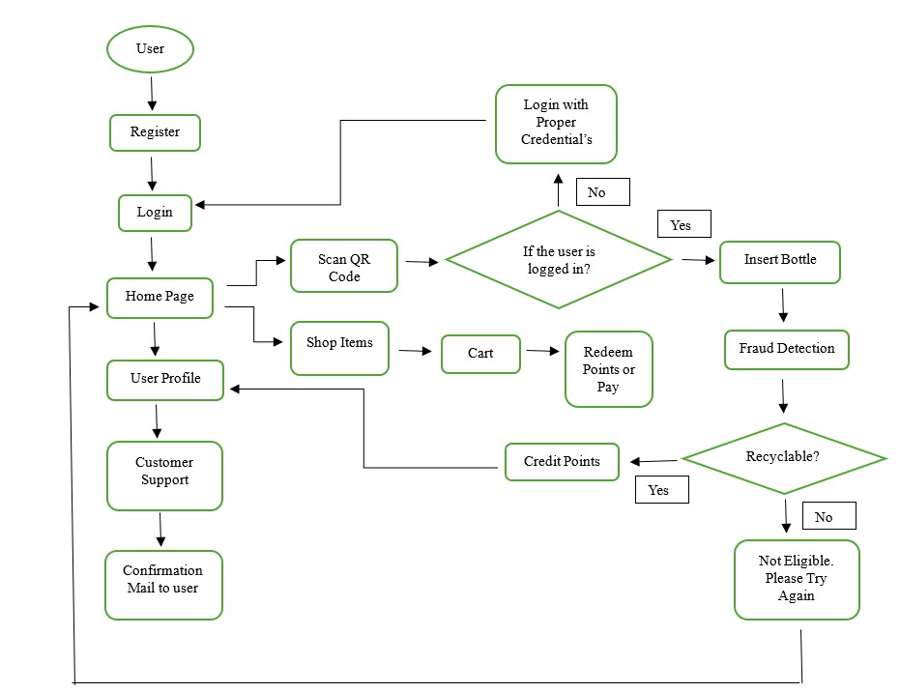

Figure 1: Workflow Diagram

**6.4 AI-Based Bottle Evaluation and Points Allocation**

* **Bottle Image Capture and Detection:** Each deposited bottle is detected using YOLO object detection, and its image is saved for further analysis.
* **AI Evaluation:** The captured image is processed by the Gemini AI model, which assesses the bottle's design, shape, color, and suitability for vending machine use.
* **Score Assignment:** Based on the AI's evaluation, a score of 10, 8, 6, or 4 is assigned to the bottle, reflecting its compatibility for vending machines.
* **Points Allocation:** The assigned AI score is directly added to the user's total points in the database, with 10 points for Excellent, 8 for Good, 6 for Average, and 4 for Poor.
* **Points Update:** Each time a bottle is detected and scored; the user's cumulative points are updated in the database according to the AI's evaluation.
* **Point Consistency:** The AI score strictly governs the point allocation, ensuring a standardized and predictable system for all bottle evaluations.
* **Failure Handling:** If the AI fails to provide a score, the system defaults to awarding 6 points, maintaining consistency in the point allocation process.

**7. SYSTEM TESTING**

**7.1 Performance Evaluation**

These performance evaluations confirm that the ReBottle Rewards platform is robust, responsive, and user-friendly, supporting efficient recycling and reward management across diverse environments and usage conditions.

1. **Response Time:** The application was evaluated for optimal page load speeds, ensuring quick access to key features such as QR code scanning, user profile, shopping, and support. Real-time bottle detection and points allocation occur with minimal delay, providing immediate feedback to users.
2. **Scalability:** The system’s scalability was tested by simulating multiple users accessing the platform simultaneously. The application-maintained responsiveness and stability, effectively handling increased loads during peak recycling and shopping activities.
3. **Real-Time Data Processing:** The AI-based bottle detection and rewards allocation were assessed for speed and accuracy. The system processes bottle images and updates user points in real time, with negligible latency between bottle deposit and points crediting.
4. **Cross-Browser Compatibility:** Comprehensive testing was performed on browsers including Chrome, Firefox, Safari, and Edge. All functionalities-QR scanning, shopping, and profile management-remained consistent and reliable across platforms.
5. **Mobile Responsiveness:** The web interface was tested on various mobile devices and screen sizes to ensure that all features, including QR code scanning and shopping, are fully functional and intuitive on smartphones and tablets.
6. **Error Handling:** Error scenarios such as invalid QR codes, failed authentication, and network interruptions were tested. The system responds gracefully, displaying clear error messages and offering users options to retry or seek support.

During system testing, multiple AI models were evaluated for plastic bottle detection and scoring accuracy. Ultralytics YOLOv8 was tested for real-time detection, while Gemini AI was used for bottle evaluation and scoring. The final deployment utilized the combination that provided the best accuracy and performance for real-world use.

|  |  |  |  |
| --- | --- | --- | --- |
| **Test Scenario** | **Expected Result** | **Observed Result** | **Pass/Fail** |
| Insert valid plastic bottle | Bottle detected, points credited, confirmation sent | Bottle detected, points credited, confirmation sent | Pass |
| Insert non-recyclable item | Item rejected, user notified | Item rejected, user notified | Pass |
| Insert valid bottle, network failure | Error message, no points credited | Error message, no points credited | Pass |
| AI fails to score bottle | Default points (6) awarded, user notified | Default points (6) awarded, user notified | Pass |
| Redeem points for product | Points deducted, order confirmation sent | Points deducted, order confirmation sent | Pass |
| Invalid login credentials | Access denied, error message shown | Access denied, error message shown | Pass |
| Scan QR code without login | Prompt for login credentials | Prompt for login credentials | Pass |

**Table 1 – Test Case Results**

Table 1 presents the test case results for the ReBottle Rewards system. It verifies that the system accurately detects bottles, assigns points, handles errors, and manages user interactions as intended. All test cases passed successfully, confirming correct functionality.

|  |  |  |
| --- | --- | --- |
| **Model Used** | **Accuracy (%)** | **Remarks** |
| Traditional CV Methods | 68.5 | Moderate accuracy, slow performance |
| Random Forest Classifier | 74.2 | Improved, but not suitable for real-time |
| Ultralytics YOLOv8 | 95.3 | High accuracy, real-time performance |
| Gemini AI (Scoring) | 97.1 | Best for scoring and classification |

**Table 2 – Accuracy Comparison of Different Models Used for Bottle Detection**

Table 2 presents a comparative analysis of the accuracy achieved by different models tested for bottle detection and scoring. The combination of YOLOv8 for detection and Gemini AI for scoring was chosen for deployment due to its superior accuracy and efficiency.

**8. RESULTS AND SNAPSHOTS**

**8.1 Results**

The ReBottle Rewards web application was rigorously evaluated to ensure reliability, responsiveness, and security across all user interactions. The application demonstrated optimal response times, with quick loading of essential features such as QR code scanning, user profile access, shopping, and customer support. Real-time bottle detection and points allocation were achieved with minimal latency, providing users with immediate feedback after each recycling action.

Scalability tests showed that the system efficiently handled multiple simultaneous users, maintaining stable performance even during peak activity periods. Load testing confirmed that the application remains robust under heavy user traffic, ensuring uninterrupted service for all participants. Cross-browser testing was conducted on Chrome, Firefox, Safari, and Edge, confirming consistent functionality and appearance across all platforms.

Mobile responsiveness was thoroughly verified, with the interface adapting seamlessly to various devices and screen sizes, including smartphones and tablets. Comprehensive error handling mechanisms were tested, with the system providing clear error messages and recovery options for scenarios such as invalid QR codes, failed authentications, and network interruptions. The authentication system and security features-including encrypted transactions and secure session management-were validated to safeguard user data and prevent vulnerabilities.

Overall, the ReBottle Rewards application met all performance, usability, and security requirements, confirming its readiness for real-world deployment as a reliable, user-friendly, and scalable platform for incentivized plastic recycling.

**8.2 Snapshots**

* **Home Page:** Displays navigation to QR code scanner, user profile, shop now, and customer support.

* **QR Code Scanner/Instruction Page:** Shows camera activation and step-by-step instructions for bottle deposit.

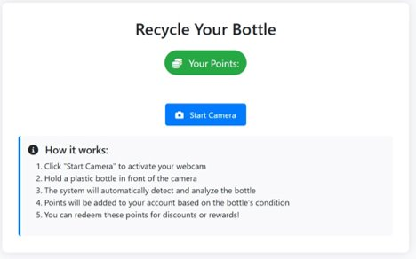

* **Shop Now Page:** Presents a filtered list of eco-friendly products available for points redemption.

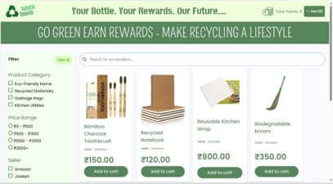

* **Cart and Points Redemption:** Displays selected items in the cart and the process for redeeming points or making payments.

* **Profile and Points Display:** Shows user’s recycling history, current points balance, and environmental impact.

* **Contact Us and Support:** Provides access to customer support and contact options.

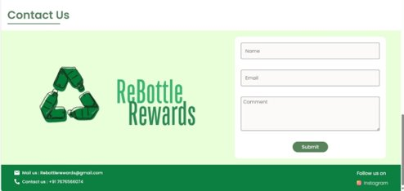

* **About Us and Bottle Journey:** Explains what happens to collected bottles and the environmental impact of user participation.

* **Bottle Detection and Points Allocation:** Captures the process of bottle image capture, AI evaluation, and points assignment.

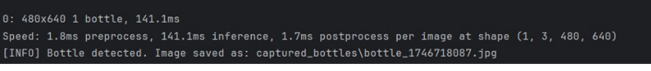

* 1. **Future Enhancements**

1. **Expand Evaluation Criteria:** Future versions can consider material recyclability and environmental impact, encouraging users to recycle more sustainable plastics.
2. **IoT Integration:** Connect with smart recycling bins and city infrastructure for real-time, location-based bottle detection and automated rewards.
3. **Support for More Recyclables:** Extend the system to accept cans, glass, and packaging, increasing environmental impact and user participation.
4. **AI Model Optimization:** Continuously improve AI accuracy and speed using larger datasets and feedback, ensuring efficient and reliable validation.
5. **Personalized User Feedback:** Provide tailored recycling tips and progress reports to users based on their recycling habits, boosting engagement.
6. **Blockchain-Based Rewards:** Implement blockchain for transparent, tamper-proof tracking of recycling transactions and reward points.
7. **Advanced Analytics Dashboard:** Add dashboards to visualize recycling trends, environmental impact, and user engagement for better decision-making.
8. **Mobile App Development:** Launch a mobile app for QR scanning, real-time notifications, and reward redemption on the go.
9. **Gamification & Social Features:** Introduce leaderboards, challenges, and social sharing to motivate users and build a recycling community.
10. **Corporate and Government Partnerships:** Collaborate with organizations for exclusive rewards, CSR initiatives, and compliance with recycling regulations.
11. **Multilingual & Accessibility Support:** Add multiple languages and accessibility features to ensure inclusivity for all users.

**CONCLUSION**

ReBottle Rewards represents a comprehensive, technology-driven response to the mounting challenge of plastic waste management. By integrating IoT-enabled collection kiosks, AI-powered bottle recognition (using Ultralytics YOLO and Generative AI), and a gamified rewards system, the platform effectively addresses key barriers identified in recent research-such as lack of convenience, limited incentives, and technical unreliability. The system’s real-time validation, secure data management, and intuitive user interface ensure that recycling becomes both accessible and engaging for a wide demographic, promoting sustained behavioral change and community participation. Furthermore, the platform’s modular architecture allows for seamless scalability and future expansion to other recyclable materials, aligning with broader smart city and circular economy initiatives.

Drawing insights from global best practices and academic studies, ReBottle Rewards places strong emphasis on user motivation, system reliability, and robust fraud prevention. By offering tangible, eco-friendly rewards and clear guidance, the project not only incentivizes responsible disposal but also fosters a culture of environmental stewardship. The integration of advanced analytics and data-driven feedback provides valuable insights for policymakers and stakeholders, supporting continuous improvement and policy refinement. In conclusion, ReBottle Rewards stands as a scalable, adaptable solution capable of transforming urban recycling habits, reducing plastic pollution, and contributing meaningfully to environmental sustainability and public well-being

**REFERENCES**

1. Kremel, A. (2023). Consumer behaviour in a circular system–how values promote and hinder the participation of young adults in the Swedish deposit-refund system for beverage packaging. Circular Economy and Sustainability, 4(2), 1427-1446.
2. Konstantoglou, A., et al. (2023). Accessing consumer perceptions of the effectiveness of the deposit refund system. Sustainability, 15(12), 9429.
3. Gito, E.G., et al. (2024). Wireless internet-connected incentive system for collecting plastic bottles. Global Science Journals, 12(3).
4. Saragih, A., et al. (2024). Spin the Bottle Bill: Deposit-Refund System Policy and Reverse Supply Chain Design. MIT Center for Transportation & Logistics Research Paper No. 2024/010.
5. Berck, P., et al. (2024). Reduce, reuse, redeem: deposit-refund recycling programmes in the presence of alternatives. Ecological Economics, 217, 108080.

**APPENDIXES – B: PUBLISHED IMPLEMENTATION PAPER**

**REBOTTLE REWARDS: AN IOT-INTEGRATED SYSTEM FOR INCENTIVIZED PLASTIC WASTE MANAGEMENT**

*Sathya Sheela D 1, Divya T 2, Sanjana V 3, Sathya Sai Sri B S 4*

1 Asst. Prof., Department of CS&D, K S Institute of Technology, Bengaluru, India ([sathyasheela@ksit.edu.in](mailto:sathyasheela@ksit.edu.in), [ORCID: 0009-0006-3555-0776])

2 Department of CS&D, K S Institute of Technology, Bengaluru, India ( [divyat51951@gmail.com](mailto:divyat51951@gmail.com) )

3 Department of CS&D, K S Institute of Technology, Bengaluru, India ( [Sanjana.mourya19@gmail.com](mailto:Sanjana.mourya19@gmail.com) )

4 Department of CS&D, K S Institute of Technology, Bengaluru, India ( [sathyasaisribs.2003@gmail.com](mailto:sathyasaisribs.2003@gmail.com) )

**Abstract**

The Plastic Waste Management and Reward System is designed to promote responsible plastic disposal by leveraging technology to incentivise users for recycling efforts. The system integrates Flask for backend processing, AngularJS, HTML, CSS, and JavaScript for a dynamic frontend, and ImageDB for cloud-based image storage. MySQL is used for secure transaction and user data management, ensuring reliability and efficiency. The platform employs AI-powered image recognition models to classify plastic waste accurately, allowing users to earn rewards based on proper disposal. Rigorous testing methodologies ensure performance, security, and scalability. Future enhancements, including blockchain-based rewards, AI-driven classification improvements, and IoT-enabled smart bins, will further optimize waste tracking and management. This project presents an innovative approach to tackling plastic waste pollution by merging technology with sustainability.

**Keywords:** Plastic Waste Management, Reward System, Recycling Incentives, Flask Backend, AngularJS Frontend, ImageDB Cloud Storage, MySQL Database, AI-powered Image Recognition, Waste Classification, Secure Transactions, Performance Testing, Security Testing, Scalability, Blockchain Rewards, IoT Smart Bins, Sustainability, Waste Tracking, Environmental Technology

**I. Introduction**

Plastic pollution remains a significant global issue, with improper disposal leading to environmental degradation and health hazards. The Plastic Waste Management and Reward System provides a technological solution by encouraging individuals to recycle plastic waste responsibly through a reward-based model. The system is built on a scalable architecture that utilizes Flask for backend processing, AngularJS for a responsive and dynamic frontend, and ImageDB for cloud-based image storage. MySQL ensures secure management of transactions and user data, making the system reliable and efficient. Users can upload plastic waste images, which are classified using AI-powered models, and receive rewards based on correct disposal.

The development process involves rigorous unit, integration, functional, and security testing to ensure system stability. Cross-platform compatibility and security measures such as encryption and authentication are incorporated to enhance user experience and data protection. By integrating smart waste tracking and incentives, the project fosters eco-friendly habits and contributes to a more sustainable waste management system.

**i. Project Purpose**

ReBottle Rewards is an innovative initiative designed to encourage sustainable plastic waste management by integrating IoT technology with an incentivized recycling system. This project enables users to deposit plastic bottles into an intelligent recycling machine, which employs AI-powered image recognition and material analysis to assess the plastic quality and determine its recyclability. Upon successful validation, the system credits reward points to the user’s account, which can be redeemed for purchases on an integrated e-commerce platform or supplemented with actual monetary transactions. The project combines both hardware and software components, ensuring a seamless and interactive user experience. The system employs Flask (Python) for backend operations, AngularJS for a responsive frontend, and ImageDB for efficient cloud-based image management, enhancing the overall functionality and user engagement.

**ii. Project Scope**

The scope of the ReBottle Rewards project encompasses the development, deployment, and integration of a smart plastic recycling incentive system. It is designed to facilitate secure user authentication, real-time AI-driven plastic quality verification, and an intuitive reward-based recycling process. Core functionalities include QR code scanning for user identification, automated plastic classification using AI-based image processing, and seamless integration with an e-commerce platform to enable reward redemption. The backend, built using Flask, handles transaction processing and system logic, while the AngularJS-based frontend provides a dynamic and user-friendly interface. AI algorithms enhance the accuracy of plastic quality assessment, reducing human error and improving efficiency. ImageDB supports cloud storage for managing image assets, ensuring reliability and scalability. The platform aims to optimize plastic waste management practices while fostering environmental responsibility through technology-driven incentives.

**II. Related Work**

**i. Anna Kremel, “Consumer Behaviour in a Circular System – How Values Promote and Hinder the Participation of Young Adults in the Swedish Deposit-Refund System for Beverage Packaging”, 19 December 2023, Springer Nature** **[1]**

The study explores how young adults in Sweden engage with the deposit-refund system (DRS) for beverage cans and PET bottles using Consumption Value Theory (CVT). Key motivators include convenience, financial incentives, and social influence, while barriers like inconvenience, time constraints, and social stigma hinder participation. Although functional values such as ease of access and rewards encourage recycling, emotional and social factors also play a role, with some feeling guilt or peer pressure. In certain social settings, recycling is stigmatized as a sign of financial need, discouraging participation. The study suggests that financial incentives alone are insufficient, as some individuals donate refunds rather than keeping them. To improve recycling rates, it recommends enhancing convenience, reducing social stigma, and leveraging technology, such as gamification and AI-powered classification, to better engage young users.

**ii. Peter Berks, Molly Sears, Rebecca L.C. Taylor, Carly Trachtman, Sofia B. Villas-Boas,” Reduce, reuse, redeem: Deposit-refund recycling Programmes in the presence of alternatives”, March 2024, Ecological Economics** **[2]**

This study examines consumer behaviour in California’s Beverage Container Recycling Program, which offers refunds for returning recyclable beverage containers. Using a discrete choice model based on survey data, it evaluates consumer willingness to pay (WTP) for different recycling methods, including kerbside collection, government-subsidized drop-off centres, and non-subsidized centres. While financial incentives boost recycling rates, decisions are also influenced by convenience, social factors, and effort required. Increasing the California Redemption Value (CRV) deposit raises recycling rates but mainly shifts consumers from kerbside collection to drop-off centres rather than increasing overall participation. The study also finds that eliminating government-subsidized drop-off centres has little impact, as consumers adapt by using processing fee centres or kerbside collection. Additionally, demographic factors like income and education shape recycling choices, with higher-income individuals preferring kerbside collection and lower-income households opting for drop-off centres for cash refunds.

**iii. Aggeliki Konstantoglou, Thomas Fotiadis, Dimitris Folinas, Athanasios Falaras and Konstantinos Rotsios,” Accessing Consumer Perceptions of the Effectiveness of the Deposit Refund System”,12 June 2023, MDPI** **[3]**

The study examines consumer perceptions of Greece’s Deposit Refund System (DRS) and its effectiveness in promoting recycling through a survey across multiple cities. Using Structural Equation Modelling (SEM), it finds that moral and environmental motives significantly influence DRS participation, with a one-unit increase in motivation improving consumer perception by 0.346 units and adoption by 0.296 units. However, barriers such as machine malfunctions, overflowing bins, unclear instructions, limited recycling points, and inadequate support hinder participation. Financial incentives alone are insufficient; consumers stress the need for greater awareness, convenience, and social reinforcement. To enhance DRS effectiveness, the study recommends improving consumer education, expanding collection points, and ensuring better system reliability.

**iv. Comparison with Existing Systems**

The ReBottle Rewards system stands out from conventional recycling platforms by integrating IoT-enabled hardware with a user-centric reward model. While systems like Canada’s Return-It Smart allow users to deposit bottles at designated stations, they lack real-time validation and dynamic reward features. Similarly, India’s Swachh Bharat Recycle App promotes awareness but relies on manual waste logging without incorporating automated sorting or incentivization mechanisms.

In the Indian context, Dry Waste Collection Centres (DWCCs) established in cities such as Bengaluru serve as decentralized waste hubs. Though some centres are beginning to adopt digital tracking, they remain largely manual and do not provide user engagement or direct rewards for responsible recycling behaviour. These systems focus more on backend processing rather than encouraging individual participation at the source.

ReBottle Rewards addresses these gaps by using QR-based authentication, ultrasonic sensors for waste detection, and servo-controlled sorting. Unlike traditional models, it also allows users to redeem accumulated points not just through a digital storefront but also for biodegradable products, reinforcing environmentally conscious behaviour. This approach promotes both technological innovation and sustainability, making ReBottle a scalable solution suitable for educational, municipal, and public environments.

Furthermore, the system’s modular design enables easy customization and integration across diverse settings without significant infrastructural changes. Its ability to function as a standalone unit with minimal maintenance makes it practical for deployment in urban as well as semi-urban environments. By combining efficient hardware operation with a reward mechanism that emphasizes sustainable consumption, ReBottle Rewards fosters long-term behavioural change, encouraging users to participate actively in plastic waste reduction efforts.

**III. Problem Identification & Statement**

**i. Problem Identification**

Plastic waste management remains a critical environmental issue due to the large volume of non-recycled plastic that accumulates in landfills and water bodies. A significant challenge in recycling efforts is the lack of automated systems that efficiently evaluate plastic quality and incentivise responsible disposal. Traditional recycling methods rely heavily on manual sorting, leading to inefficiencies, contamination, and a reduced recycling rate. Additionally, the lack of consumer motivation and awareness further exacerbates the issue.

The Rebottle Rewards project addresses these challenges by providing an AI-driven recycling solution that automates plastic quality assessment and integrates a reward-based incentive system. By leveraging AI for plastic classification and IoT for machine automation, this project enhances accuracy and efficiency in plastic waste processing. Users are encouraged to recycle through a transparent, technology-driven approach that tracks their contributions and rewards their participation. The integration of a digital platform allows users to monitor their recycling activities, redeem rewards, and contribute to sustainable practices effortlessly.

**ii. Problem Statement**

The ReBottle Rewards system is designed to tackle the challenges associated with plastic waste management, including inefficient sorting mechanisms, lack of user engagement, and limited incentives for responsible recycling. Traditional recycling processes involve extensive manual labour, which is time-consuming, error-prone, and often leads to misclassification of plastic waste. Furthermore, the absence of a structured incentive system discourages individuals from participating in recycling Programmes.

This project aims to provide an efficient and automated solution that employs AI-driven plastic quality assessment to classify recyclables accurately. By integrating IoT-enabled smart machines with a reward-based system, ReBottle Rewards encourages active user participation. The platform offers real-time data insights, seamless reward redemption, and an interactive user experience through its web-based interface. By streamlining the recycling process and incorporating gamified incentives, the system fosters environmental consciousness and promotes responsible waste disposal at a broader scale.

**IV. Goals & Objectives**

The ReBottle Rewards system aims to create an intelligent and user-friendly platform that incentivizes plastic recycling through AI-based authentication and IoT-enabled automation. By integrating real-time plastic quality assessment and a structured rewards model, the system enhances recycling participation while promoting environmental sustainability. It ensures a seamless user experience through efficient authentication, transparent reward allocation, and an accessible digital interface.

Key objectives include automating plastic classification using AI for accurate recyclability assessment and enabling quick user interaction through QR-based authentication. A structured points-based incentive system encourages consistent recycling, while multi-device accessibility ensures scalability. The system is designed to foster sustainable waste management practices by making recycling convenient, engaging, and rewarding for users.

**V. System Requirements**

**i. Software Requirements**

The system is built on a scalable architecture, utilizing Flask for backend processing, AngularJS for a dynamic frontend, and ImageDB for cloud-based image storage. MySQL ensures secure transaction and user data management, while development is conducted using Visual Studio Code for coding and debugging.

**ii. Hardware Requirements**

The system is built using an Arduino UNO R3 Clone Microcontroller as the core processing unit, integrated with a Breadboard GL-12800 for circuit layout. An Ultrasonic Sensor HCSR04 detects plastic waste placement, while a SG90 Servo Motor (180 Degrees) enables controlled sorting. The ESP32 CAM Development Board with an OV2640 Camera Module captures images for classification, supported by an Arduino Wi-Fi module for cloud connectivity. Jumper wires facilitate stable data transmission between components. This setup ensures efficient waste identification, processing, and remote monitoring, with scalability for future AI integration and enhanced plastic waste tracking.

**VI. Project Design**

**i. Workflow Design**

The ReBottle Rewards system provides an efficient recycling process integrated with a rewards-based shopping experience. As shown in Figure 1, the process begins with user registration and login. Once authenticated, upon successful login, they reach the home page, where they can either scan a QR code to connect to a bottle deposit machine, access customer support, or proceed to the "Shop Now" section.

When a user scans the QR code, the system establishes a connection with the deposit machine. The user can then insert a bottle, which undergoes a fraud detection to determine if it is recyclable. If the bottle is not eligible, the user is notified to try again.

If accepted, reward points are credited to the user’s account. Users who choose "Shop Now" are redirected to the shopping section, where they can add items to their cart and complete transactions using either their earned reward points or standard payment methods. Customer support is available for assistance, and confirmation emails are sent for key interactions. The system ensures data security through authentication protocols and encrypted transactions, maintaining user privacy and operational efficiency.

**ii. User Authentication and Security**

User authentication is secured through login credentials, ensuring only verified users access the platform. Multi-factor authentication (MFA) enhances security, while session management ensures auto-logout for inactive users. Based on authentication, users are redirected to their dashboard, where they can track rewards, manage their profile, and engage with the system. Unauthorized users attempting to access restricted areas are redirected to the login page, maintaining system integrity and security.

**VII. Implementation**

**i. Backend – Python (Flask)**

The backend of the ReBottle Rewards system is developed using Python, leveraging the Flask framework for efficient transaction handling, API integration, and user authentication. Python's robust data processing capabilities enable seamless communication between the smart recycling machine, the database, and the web application. Flask provides a lightweight yet scalable architecture, allowing smooth interaction between the user interface and the backend while managing reward allocation, user authentication, and transaction records. The integration with MySQL ensures secure data storage, while APIs facilitate real-time plastic quality validation and reward point updates.

**ii. Frontend – HTML, CSS, JavaScript (AngularJS)**

The frontend of the ReBottle Rewards system is built using HTML for structuring web pages, CSS for styling and responsive design, and JavaScript, specifically AngularJS, for dynamic interactivity. The user interface includes login and registration pages, a dashboard displaying reward points and recycling history, and navigation options to scan a QR code, access the shopping section, or contact support. CSS ensures a visually appealing and mobile-friendly layout, while JavaScript manages form validation, dynamic content updates, and seamless API communication. The frontend dynamically retrieves and displays user transactions, reward balances, and shopping cart details, ensuring a smooth and engaging user experience.

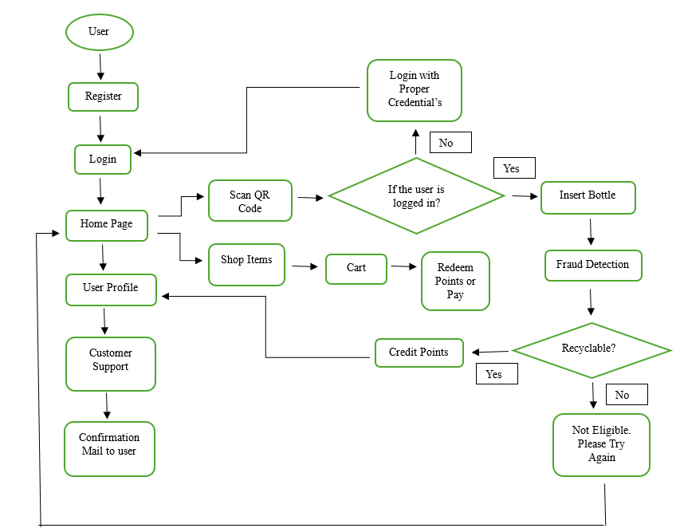

**Figure 1: Workflow of ReBottle Rewards**

**VIII. Adoption Potential**

The ReBottle Rewards system holds significant potential for widespread adoption across various public and institutional environments due to its modular design, user-friendly interface, and sustainability-driven incentive model. In municipal settings, the system can be integrated into smart city infrastructure to support local waste management initiatives. By strategically placing ReBottle units in public parks, markets, and transit hubs, municipalities can promote responsible plastic disposal while actively engaging citizens in environmental conservation. The system’s ability to log individual contributions and distribute rewards can be tied to local government sustainability campaigns, thereby enhancing public participation and awareness.Educational institutions such as schools, colleges, and universities present another ideal environment for deployment. ReBottle can serve as both a practical recycling tool and an educational aid, promoting environmental consciousness among students through gamified participation and reward-based motivation. Institutions can incorporate the system into campus sustainability programs, encouraging students to earn points for plastic waste deposits and redeem them for eco-friendly products or campus-based incentives, such as bookstore discounts or cafeteria vouchers.In the commercial and corporate sector, ReBottle can be implemented in shopping malls, office complexes, and corporate campuses to align with organizational sustainability goals. Businesses adopting green policies can use the system as part of their Corporate Social Responsibility (CSR) initiatives, offering incentives to employees and visitors who engage in recycling. Additionally, its compatibility with digital platforms and low-maintenance design ensures that ReBottle can be deployed with minimal operational overhead, making it a viable solution for long-term use in both high-traffic and community-oriented spaces. Its adaptability, combined with the positive behavioural impact it fosters, positions ReBottle as an effective tool for promoting environmentally responsible habits across multiple sectors.

Moreover, the system’s data-driven functionality allows administrators to monitor usage patterns, track recycling volumes, and generate insightful reports for planning and policy-making. This analytical capability not only supports continuous improvement of waste management strategies but also enables measurable impact assessment, making ReBottle a valuable asset for institutions committed to transparency and environmental accountability.

**IX. Results**

**i. Website Pages**

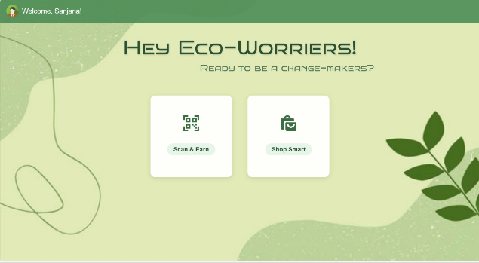

**Figure 2: Home Page**

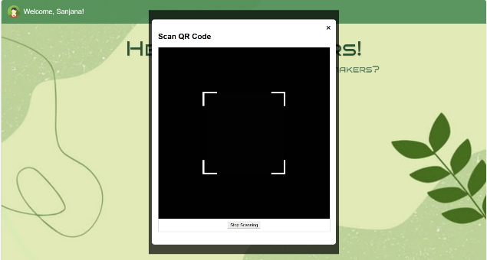

**Figure 3: QR Code Scanner**

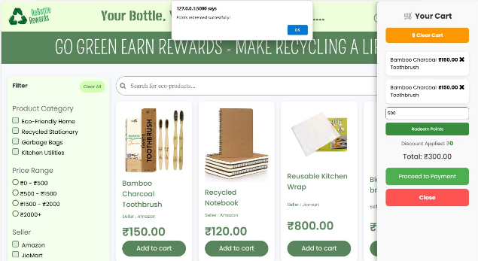

**Figure 4: Shop Now Page with Cart and Points Redemption**

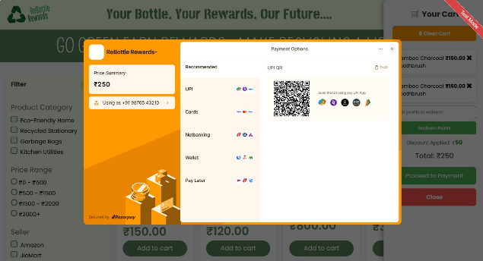

**Figure 5: Payment Page**

Figures 2 to 5 illustrate the core interfaces of the ReBottle Rewards platform, emphasizing a user-centric design and seamless navigation. Figure 2 displays the Home Page, which acts as the main dashboard after login. It includes quick navigation options such as Scan Here and Shop Now, along with access to the user's Profile section. The layout is clean and intuitive, designed to ensure ease of access for users of varying age groups and digital literacy levels. Figure 3 presents the QR Code Scanner interface, enabling users to securely link their device with a recycling unit. The scanner initiates a verified session and facilitates real-time tracking of individual recycling activity, compatible across mobile and desktop platforms.

Continuing through the system, Figure 4 highlights the Shop Now Page, where users can browse and redeem their reward points for eco-friendly products or daily-use items. This module includes features like a shopping cart, product listings, and point balance display to simplify the shopping experience. Lastly, Figure 5 showcases the Payment Page, where users complete their redemption using either reward points or a hybrid payment method. The interface employs secure protocols to protect user data and ensure a smooth, trustworthy checkout process, thereby enhancing overall user satisfaction.

**ii. Testing Outcomes**

The ReBottle Rewards system was tested over a five-day trial involving 15 users, during which 140 plastic bottles were deposited. Of these, 135 transactions were successfully processed, reflecting a 96.4% success rate. The average response time from QR scan to confirmation was 1.4 seconds, ensuring a quick and efficient user interaction.User feedback indicated that 88% of participants found the system easy to use and appreciated the clarity in reward tracking. On average, users earned 12–20 points per session, which were successfully redeemed through the integrated reward module, including options for biodegradable product redemption.Technically, the system maintained 97.5% uptime, and the ESP32-CAM and sensor components performed reliably under continuous operation. Image data captured during testing had a 92% success rate in validation. The system interfaces, shown in Figures 2 to 5, supported a smooth experience across key functions such as login, QR scanning, shopping, and payment processing, demonstrating the platform’s readiness for wider deployment.

**X. Testing Methodology**

The **ReBottle Rewards system** underwent rigorous testing to ensure its reliability, security, and efficiency across all components. Various testing methodologies were applied to validate both functional and non-functional aspects of the system.

**Unit Testing:** Individual components, including QR-based user authentication, AI-driven plastic classification, and reward point calculations, were tested to confirm their accuracy and reliability.

**Integration Testing:** The interaction between the frontend, backend, and MySQL database was validated to ensure seamless data flow. The QR code scanning module, reward distribution system, and user authentication were tested for smooth integration.

**Functional Testing:** Core features such as user authentication, plastic classification, reward redemption, and transaction tracking were thoroughly tested to ensure correct operation. Edge cases, such as incorrect QR codes or invalid plastic submissions, were also considered.

**Performance Testing:** The system's response time and efficiency were analysed under different workloads using tools like JMeter. High-load scenarios, such as multiple concurrent QR scans and reward redemptions, were tested to ensure stable system performance.

**UI & Usability Testing:** The user interface was evaluated for intuitive navigation, responsiveness across various devices, and accessibility compliance. The system maintained an optimal user experience across mobile and web platforms.

**Security Testing:** Security vulnerabilities such as SQL injection, authentication bypass, and cross-site scripting (XSS) were assessed. Data encryption was implemented for sensitive information, and secure session management was verified.

**Compatibility Testing:** The system was tested on multiple browsers (Chrome, Firefox, Edge, Safari) and devices (Windows, macOS, Android, iOS) to ensure consistent user experience and functionality across all platforms.

**Regression Testing:** Test cases were rerun after feature updates to verify that no existing functionalities were affected. Automated tests ensured system stability after modifications.

**Beta Testing (User Acceptance Testing - UAT):** A beta version of the system was released to a select group of users. Real-world feedback on usability, system responsiveness, and feature effectiveness was collected and analysed. Necessary refinements were made based on user input.

**Final Deployment & Monitoring:** The system was deployed to a staging environment for final validation. Analytics tools were used to monitor system errors, user interactions, and performance metrics post-launch. Continuous improvements were made based on real-time data and user feedback.

**XI. Future Enhancements**

• **AI-Driven Plastic Classification Improvements:** Enhance the AI model to Recognise a wider range of plastic types with higher accuracy, improving sorting efficiency and recyclability assessment.

• **Gamification & Leaderboards:** Introduce gamification features such as leaderboards, achievement badges, and reward milestones to encourage user participation and long-term engagement.

• **Mobile App Development:** Expand the platform with a dedicated mobile application for seamless QR code scanning, reward redemption, and recycling tracking on the go.

• **Multi-Language Support:** Integrate multilingual support to cater to diverse users and promote sustainability awareness across different regions.

• **Enhanced Security Measures:** Implement multi-factor authentication (MFA), biometric login, and encrypted storage for safeguarding user data and transactions.

• **Corporate & Institutional Collaborations:** Expand partnerships with businesses, schools, and municipalities to implement large-scale recycling Programmes and reward initiatives.

**Conclusion**

The Plastic Waste Management and Reward System successfully integrates Flask, AngularJS, ImageDB, and MySQL to create an efficient and scalable platform for incentivizing responsible waste disposal. The system's AI-driven classification, secure transactions, and intuitive frontend provide a seamless experience for users while encouraging eco-friendly practices. Through comprehensive testing and validation, the platform ensures reliability, security, and cross-platform compatibility. Future developments, such as blockchain-based rewards, IoT-enabled smart bins, and advanced AI classification models, will further enhance the system's functionality. This project not only promotes environmental sustainability but also fosters a community-driven approach to plastic waste reduction, paving the way for a cleaner and more responsible society.

**Author Contributions**

1. Prof. Sathya Sheela D: Project supervision, technical mentoring, and evaluation strategy.
2. Divya T: Hardware module development, including sensor integration and Arduino programming.
3. Sanjana V: Backend development using Flask, MySQL integration, and AI model training for plastic classification.
4. Sathya Sai Sri B S: Frontend development using AngularJS, UI/UX design, and responsive layout structuring.

**References**

1. Kremel, Anna. "Consumer behaviour in a circular system–how values promote and hinder the participation of young adults in the Swedish deposit-refund system for beverage packaging." *Circular Economy and Sustainability* 4, no. 2 (2024): 1427-1446.
2. Berck, Peter, Molly Sears, Rebecca LC Taylor, Carly Trachtman, and Sofia B. Villas-Boas. "Reduce, reuse, redeem: Deposit-refund recycling Programmes in the presence of alternatives." *Ecological Economics* 217 (2024): 108080.
3. Konstantoglou, Aggeliki, Thomas Fotiadis, Dimitris Folinas, Athanasios Falaras, and Konstantinos Rotsios. "Accessing consumer perceptions of the effectiveness of the deposit refund system." *Sustainability* 15, no. 12 (2023): 9429.

**APPENDIX – C: CERTIFICATE OF IMPLEMENTATION PAPER**